10.32:

a) 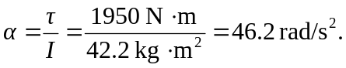
b)
c) From either 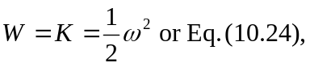

d), e) The time may be found from the angular acceleration and the total angle, but the
instantaneous power is also found from 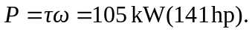 The average power is
half of this, or 